Sending with a dynamic IP address / sending via SMTP authentication

Sending e-mails via MPmail with a dynamic IP address is possible with SMTP authentication. To do this, a function user must be created in the Control Panel, which is used for authentication.

Sending using SMTP authentication is set up as follows:
- create a function user in the control panel (e.g.: sending@yourdomain.com)
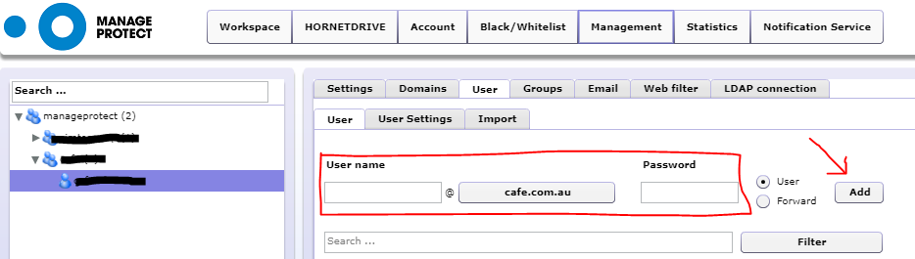

- Setting up Advances Routing for the user. The radio button for POP3/IMAP must be set.
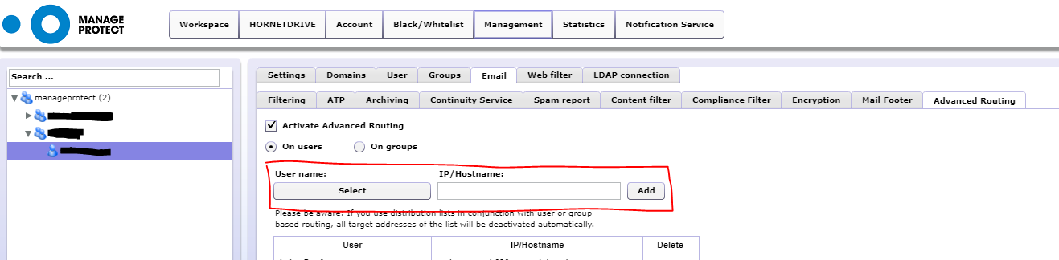

- After about 60 minutes, enter <main customer domain>.relay.cloud-security.net in your mail server as Smarthost / Relayhost.

- In addition, activate SMTP authentication on the mail server and store the newly created user with the corresponding password.

